EEL 4930/5934 BioSignals Processing

Assignment 1- Due: September 11

Please write a report answering the following questions. Submit the report and all the m-files you used to answer the questions on Blackboard in Module Assignments / Assignment 1.

1. Write MATLAB code to
   1. Download, read and plot channel 1 only of the data file edbe0103.mat.
      1. What is the duration of the ECG signal in seconds? The duration is 7200 seconds
      2. How is the length of the ECG signal in samples? The length is 1.8 million samples per channel.
      3. What is the sampling rate? The sampling rate is 250 Hz.
   2. Find an estimate of the heart rate by measuring the duration between consecutive R waves. Save them in a vector called TH. First element of TH should be the distance between the first and second R waves, the second element of TH should be the distance between the second and third R waves and so on.   
      For this exercise, you may see that I took the difference between max(n+1) and max(n);  
      This difference vector comprised TH. The mean of TH was 243.35.  
      Considering our sampling rate of 250 per second, this means that we had a beat, on average, on every second. This gives us an average heart rate of about 60 beats per minute.
   3. Plot TH versus the given time vector tm (discard the last point of tm so that TH and tm are the same length). The plot of TH is seen on the attached matlab file.
   4. Find the mean and variance of TH. These items are mentioned and exercised in the matlab files and matlab output pdf. Please see attached. Mean(TH)=243.35;
   5. Comment on any observations, difficulties or aberrations you encounter.  
      Challenges on this exercise included: Building the algorithms to analyze the signals and plot the correct notations. Review the syntax of matlab and it's hidden functions. Finally, revisiting the signal analysis mindset, theories and intricacies (still in progress).

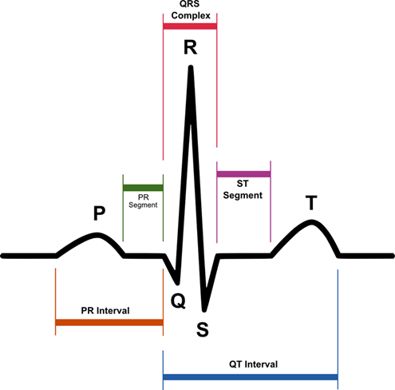

1. Please read
   1. the paper “Research on ECG Niometric in Cardiac Irregularity Conditions” by Wang and Zhang, Proceedings of the 2014 International Conference on Medical Biometrics.  
      The authors are proposing to use the properties of a heart function to identify people.   
      It is asserted that there exists a problem and growing concern with identity and identity security. Thus the paper explores how to do this through the analysis of the EKG and the proposed algorithms.   
      The paper has sound data and creative work (meaning the new proposition), however there are many challenges with the identification of a person's identity through their heart characteristics. One of the main problems is the volatility that a heart contains.   
      The heart changes with the various life phases, diets and habits in general.   
      Thus the proposed method for identity holds too many variables that contribute to risk and failure of any identity matching mechanism.   
      In addition, it must be noted that most of these signals were retrieved in controlled conditions. A system that proposes to identify a user through it's heart characteristics must be apt for much more than controlled conditions.
   2. Study the code Assignment1NE3.m.
      1. Use the output xx of the correlation filter to redo question 1.b.  
         The new output proposes a much larger array of maxima. From closer, eye inspection, I was able to note that many of the new maxima that appear on the new plot are due to a superimposed and higher T waves. Thus, through the addition of the filter and autocorrelation factors, it is possible easy the identification of heart behavior.   
         A challenge in this portion of the exercise was the time put in to review the Fourier and DSP concepts, so to make better sense of the operations and paper content.
      2. At each peak, compute the correlation coefficient[1] to determine if a peak is part of a QRS wave or not. Mark your plot to indicate the answer.  
         The correlation coefficient is discussed in the page attached to this document.   
         As remarked, it is a product of the Covariance of the Test signal and the Template signal, divided with the root of the expectation of each discrete signal.   
         Please refer to the attached pdf.   
         Due to time constraints it was a bit difficult to finish the whole correlation portion.

1. Correaltion coefficient is described in the referenced paper, as well as Part 1 of Biomedical Signal Processing by Challis and Kitney. If you have questions about how to compute and how to use it, start or join an online discussion. I will answer your questions there if I need to.